Contents
1 Introduction 3
1.1 Purpose and Scope 3
2 Design Overview 3
2.1 Changes Required 3
3 Detailed Design 4
3.1 MShutdownEventObserver Interface 4
3.2 CServShutdownServer Implementation Changes 4
3.2.1 HandleShutdownEventL Event Handling 5
3.2.2 Power API Usage 5
3.2.3 ClientArrayLC 5
3.2.4 IsClientHung 5
3.2.5 GetShutdownState 6
3.3 Final Design 7
3.3.1 Class Diagram 7
3.3.2 Sequence Diagram for Restart Event 8
4 Further Information 9
4.1 People 9
4.2 References 9
4.3 Open Issues 9
4.4 Glossary 9
4.5 Document History 9

Introduction

Purpose and Scope
This document describes the changes required to Shutdown Manager (pwrcli) in order to satisfy the requirement REQ 6883 “Base Shutdown Server shall support device restart” of PREQ1089 “Process Monitoring and Re-launch Service”. See [R1] for 1089 Design Sketch that contains detailed information.
This PREQ is required for Oghma. The PTS for this PREQ is UI Frameworks.
The target audience that this document is intended includes the TA and engineers within System Libraries, UI Frameworks, Test Engineering and the PM responsible for the PREQ delivery.

Design Overview
PREQ1089 requires that the Shutdown Server should support restarting the OS. The system should be able to restart either in a default start-up mode or a defined specific start-up mode.
Shutdown server currently supports only powering down of the OS or going into Standby mode.
An existing interface which has been used to pass shutdown requests to Shutdown Server will be extended to support processing OS restart requests.

Changes Required
The high level changes required to satisfy PREQ1089 follow:
- The existing event observer interface MShutdownEventObserver will be extended to be able to receive restart requests.
- The server class CServShutdownServer implementing the interface will be updated to receive and process the restart request.
- CServShutdownServer will also be updated to replace usage of UserHal::SwitchOff() API with Power API’s.

Detailed Design

MShutdownEventObserver Interface
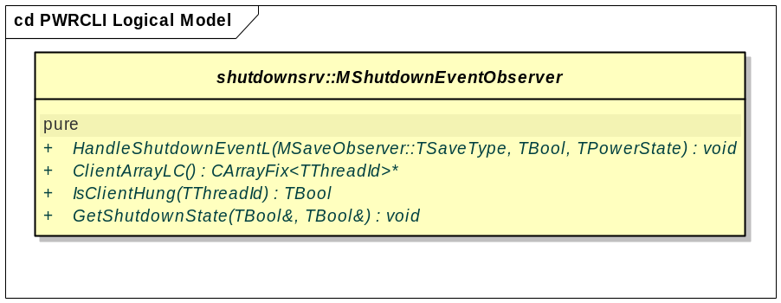
The main change in MShutdownEventObserver is the addition of an extra parameter to the end of the HandleShutdownEventL interface:
virtual void HandleShutdownEventL(MSaveObserver::TSaveType aAction,TBool aPowerOff, TPowerState aEvent = EPwStandby)=0;
This new parameter will be used by the implementation to pass this value to Base Power API’s to select between different power-down methods. The default value of the parameter is used to provide backwards-compatible behaviour. Prior to this change, the only supported power-down method was standby.
The use of TPowerState as the type of this new parameter will require users of this API (LaF Shutdown Manager and licensee replacements) to convert their internal off-event codes to corresponding power states before calling this API.

CServShutdownServer Implementation Changes
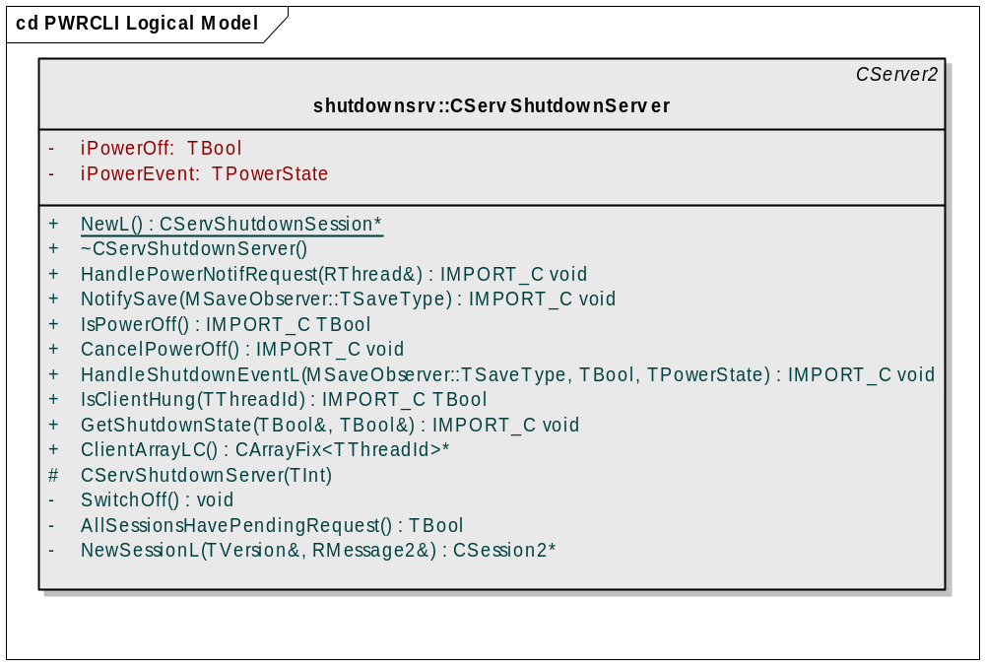
In order to accommodate the changes in the interface, HandleShutdownEventL method of CServShutdownServer will be changing. A new data member iPowerEvent will be introduced. Another change in this class is to replace the use of UserHal::SwitchOff() by Power API in order to prepare the old UserHal API for depreciation and enable use of the more flexible new APIs.

HandleShutdownEventL Event Handling
The main change in HandleShutdownEventL is the addition of an extra parameter to the end to reflect the change in the virtual interface:
IMPORT_C void HandleShutdownEventL(MSaveObserver::TSaveType aAction,TBool aPowerOff, TPowerState aEvent = EPwStandby);
In the implementation of this function, the value passed will be assigned to the newly introduced data member iPowerEvent.
When the Shutdown Server finishes notifying registered clients of the pending event, it will call SwitchOff method to finalize powering down the device. iPowerEvent will be used in SwitchOff as a parameter to Power API.

Power API Usage
The existing SwitchOff method will be modified to use Power API instead of the current method of calling UserHal::SwitchOff(). That function call will be replaced with the following block of code:

// restart or standby/shutdown using Power API
if (Power::EnableWakeupEvents(iPowerEvent) == KErrNone)
{
// Prepare to wake up if power event is standby
TRequestStatus s;
Power::RequestWakeupEventNotification(s);
Power::PowerDown(); // if restart, this function should never return
User::WaitForRequest(s);
}

Depending on the value of the iPowerEvent parameter, the Power API functions will cause the device power state to be modified. In the case of standby, the wakeup events will cause the device to wake up and the execution will continue after User::WaitForRequest as usual. In the restart and power-off cases, the Power::PowerDown() API will never return and the device will be power-cycled (causing the OS to reboot) or powered off.

ClientArrayLC
This method creates an array of thread ids of clients registered for shutdown notification. It uses CArrayFix<TThreadId> and instance of it is pushed on the cleanup stack and returns a pointer to the same.

This method iterates through all the registered sessions and appends its thread id to CArrayFix only if it is not added previously in the array i.e. duplicate entries for the same thread id is avoided because one thread can have many sessions registered.

IMPORT_C CArrayFix<TThreadId>* ClientArrayLC();

IsClientHung
This method checks whether a client which is registered for shutdown notification is hung or not by checking whether client thread has any pending request or not.
It iterates through all the sessions and finds the specified thread id i.e. aId, If it finds the same then it checks for pending request using HasPendingRequest().
IMPORT_C TBool IsClientHung(TThreadId aId) const;

The method returns ETrue if client is hung otherwise EFalse.

GetShutdownState
This method returns information about the shutdown status.

IMPORT_C void GetShutdownState(TBool& aPowerOff, TBool& aAllSessionsHavePendingRequest) const;

It has two output parameter aPowerOff and aAllSessionsHavePendingRequest

On return aPowerOff is ETrue if a powerdown sequence has been initiated, otherwise EFalse. This is the value stored in iPowerOff.

On return aAllSessionsHavePendingRequest contains ETrue if all registered clients have pending requests otherwise EFalse. It uses AllSessionsHavePendingRequest()to get the same.

Final Design

Class Diagram
The class diagram of the component for the final design will be as follows:
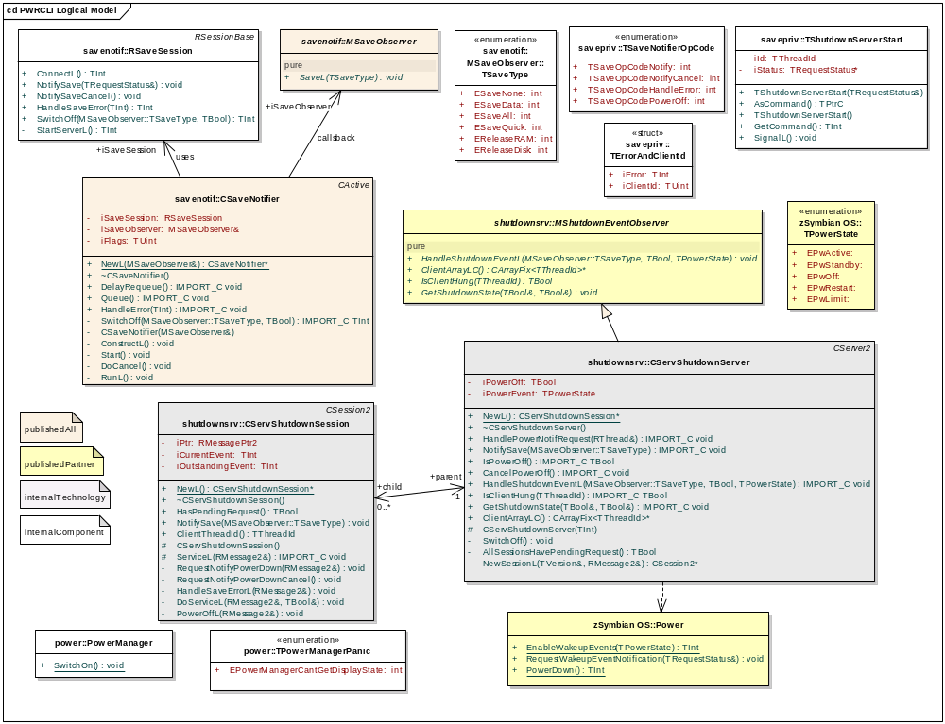

Sequence Diagram for Restart Event
The sequence diagram for a restart event will be as follows:
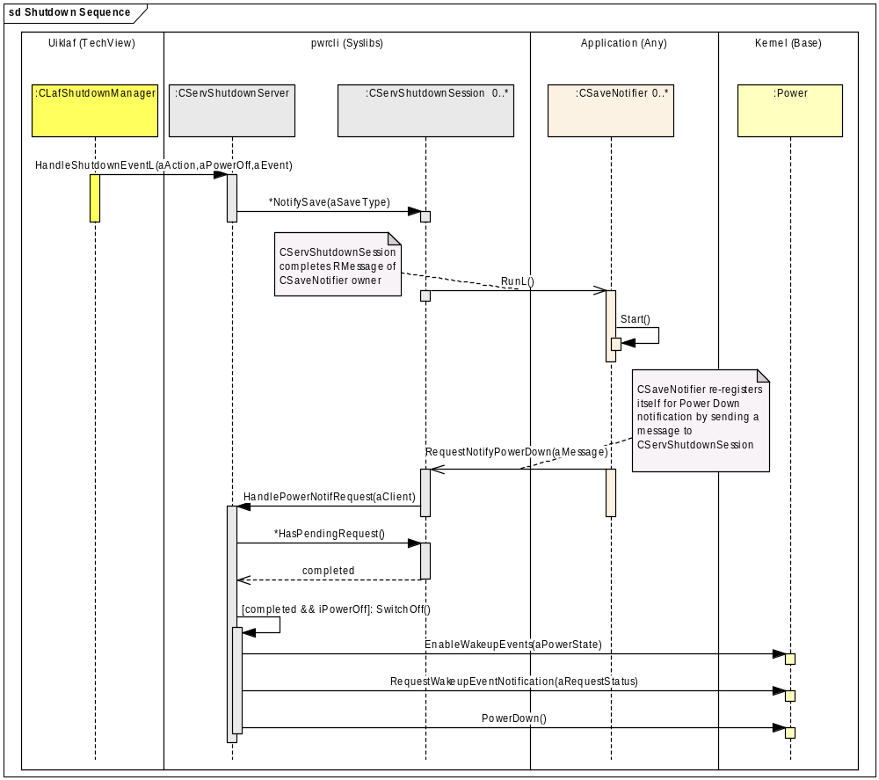
- CLafShutdownManager will call HandleShutdownEventL( ESaveAll, ETrue, EPwRestart)
- HandleShutdownEventL will save EPwRestart in iPowerEvent and call NotifySave.
- CServShutdownServer::NotifySave will in turn call all CServShutdownSession’s NotifySave()’s.
- CServShutdownSession::NotifySave() will complete pending requests, triggering CSaveNotifier’s RunL()’s.
- CSaveNotifier::RunL() will handle application specific save operations and then re-register for power-down notifications by sending a message to CServShutdownSession.
- CServShutdownSession’s ServiceL() will process the message and RequestNotifyPowerDown() will be called.
- RequestNotifyPowerDown() will call CServShutdownServer::HandlePowerNotifRequest().
- HandlePowerNotifRequest() will iterate through all registered CServShutdownSession’s to check if all of them re-registered by calling HasPendingRequest()
- If all are complete, SwitchOff() will be called.
- SwitchOff() will call Power API functions with the saved value of iPowerEvent to restart the device.

Further Information
None.

People
Role | Person / People
Reviewers | Stephen Mansfield, Phil Hodgson,Swapnel Shrivastava
Contributors | Aleks Pamir, Sanjeev Kumar

References
No. | Document Reference | Version | Description
[R1] | SGL.SM0011.008 PREQ1089_DesignSketch.doc | 0.10 | Design Sketch for PREQ 1089 - Process Monitoring and Re-launch Service

Open Issues
None

Glossary
Term | Definition

Document History
Date | Version | Status | Author | Description
23-01-2009 | 1.1 | For Review | Sanjeev Kumar | Added the description of the followinf API’s ClientArrayLC, IsClientHung, GetShutdownState
08-12-2006 | 1.0 | Issued | Stephen Mansfield | Updated TOC and issued document.
07-12-2006 | 0.2 | For Review | Aleks Pamir | Updated after review comments
23-11-2006 | 0.1 | Draft | Aleks Pamir | First draft based on SGL.PPS001.501 Formal Document Template Rev 8.6

